Trajectory Conversion Algorithm-PARAMICS Software User Manual

Version 2.3

www.its.dot.gov/index.htm

**Draft Report — December 2014   
Publication Number: FHWA-JPO-XX-XXX**



Federal Highways Administration

| **Notice**  This document is disseminated under the sponsorship of the Department of Transportation in the interest of information exchange.  The United States Government assumes no liability for its contents or use thereof.  The U.S. Government is not endorsing any manufacturers, products, or services cited herein and any trade name that may appear in the work has been included only because it is essential to the contents of the work. |
| --- |

Produced by Noblis, Inc.

U.S. Department of Transportation

ITS Joint Program Office

|  |  |  |  |  |  |  |
| --- | --- | --- | --- | --- | --- | --- |
| **Technical Report Documentation Page** | | | | | | |
| **1. Report No.**  **FHWA-JPO-XX-XXX** | **2. Government Accession No.** | | | **3. Recipient’s Catalog No.** | | |
| **4. Title and Subtitle**  **Trajectory Conversion Algorithm –PARAMICS Software User Manual Version 2.3** | | | | **5. Report Date**  December 31, 2014 | | |
| **6. Performing Organization Code** | | |
| **7. Author(s)**  Taylor Deurbrouck, Richard Glassco, Jim Larkin, Dr. Karl Wunderlich, Sandeep Mudigonda, Dr. Kaan Ozbay | | | | **8. Performing Organization Report No.** | | |
| **9. Performing Organization Name And Address**  Noblis  600 Maryland Ave., SW, Suite 755  Washington, DC 20024 | | | | **10. Work Unit No. (TRAIS)** | | |
| **11. Contract or Grant No.** | | |
| **12. Sponsoring Agency Name and Address**  ITS-Joint Program Office  1200 New Jersey Avenue, S.E.  Washington, DC 20590 | | | | **13. Type of Report and Period Covered**  Draft Report | | |
| **14. Sponsoring Agency Code**  **HOIT-1** | | |
| **15. Supplementary Notes** | | | | | | |
| **16. Abstract**  The Trajectory Conversion Algorithm (TCA) Software is designed to test different strategies for producing, transmitting, and storing Connected Vehicle information. The PARAMICS add-on (TCA-P) runs with the PARAMICS tool using real-time simulation vehicle information, Roadside Equipment (RSE) location information, cellular region information, event region information, and strategy information to produce a series of snapshots that the vehicle would produce. Vehicles can be equipped to generate and transmit Probe Data Messages (PDMs), Basic Safety Messages (BSMs), ITS SPOT messages, and/or European CAM which can be transmitted by either Dedicated Short Range Communication (DSRC), cellular, or both. | | | | | | |
| **17. Key Words**  Connected Vehicles, Basic Safety Message, Probe Data Message, DSRC, Cellular, V2I, Mobility | | | **18. Distribution Statement** | | | |
| **19. Security Classif. (of this report)**  Unclassified | | **20. Security Classif. (of this page)**  Unclassified | | | **21. No. of Pages**  31 | **22. Price**  **N/A** |
| **Form DOT F 1700.7 (8-72) Reproduction of completed page authorized** | | | | | | |

Table of Contents

1 Introduction 5

1.1 Features added in Build 3 5

2 Installation and Running the TCA-P 6

2.1 Running TCA-P 6

2.2 Modifying TCA-P 6

3 Input Files 9

3.1 File Requirements to Run the TCA-P 9

3.2 Control File 9

3.2.1 Vehicle Equipage 9

3.3 RSE Location File 13

3.4 Strategy File 14

3.5 Regions File 18

3.6 ITS Spot Device Location File 23

4 Output Files 25

4.1 TCA Input Summary File 25

4.2 Transmitted PDMs File 25

4.3 All PDM Snapshots File 26

4.4 Transmitted BSM File 27

4.5 Transmitted CAM File 28

4.6 ITS Spot Travel Records 29

4.7 ITS Spot Behavior Records 30

List of Tables

Table 3‑1: Symbol key 9

Table 3‑2: Control file fields 10

Table 3‑3: RSE location file fields 13

Table 3‑4. Symbol Key 14

Table 3‑5: Strategy file fields 14

Table 3‑6: Regions file elements 19

Table 3‑7: ITS Spot device file fields 23

Table 4‑1. TCA Input Summary file fields 25

Table 4‑2: Transmitted PDMs file fields 25

Table 4‑3: All PDM snapshots file fields 27

Table 4‑4: Transmitted BSM file fields 28

Table 4‑5: Transmitted CAM file fields 29

Table 4‑6: ITS Spot Travel Record file fields 30

Table 4‑7: ITS Spot Behavior Record file fields 30

List of Figures

Figure 3‑1: Control File example 13

Figure 3‑2. RSE Locations File Example 14

Figure 3‑3: Strategy input file example 18

Figure 3‑4: Example of regions over a simple intersection network 19

Figure 3‑5: Example regions input file with one cellular region 21

Figure 3‑6: Example region input file using the standard deviation method 22

Figure 3‑7: Example regions input file using probability and Poisson distribution methods 23

Figure 3‑8: Sample ITS Spot device location file 24

Figure 4‑1. TCA Input Summary file example excerpt 25

Figure 4‑2: ITS Spot travel records example excerpt 30

Figure 4‑3: ITS Spot behavior records example excerpt 31

# 

# Introduction

The Trajectory Conversion Algorithm (TCA) Software is designed to test different strategies for producing, transmitting, and storing Connected Vehicle information. The PARAMICS add-on (TCA-P) runs with the PARAMICS tool using real-time simulation vehicle information, Roadside Equipment (RSE) and/or ITS Spot device location information, cellular region information, event region information, and strategy information to produce a series of snapshots that the vehicle would produce. Vehicles can be equipped to generate and transmit Probe Data Messages (PDMs), Basic Safety Messages (BSMs), ITS Spot messages, and/or European Cooperative Awareness Messages (CAM) which can be transmitted by either Dedicated Short Range Communication (DSRC), cellular or both. The TCA program Version 2 Build 3 or 2.3 assumes perfect communication between vehicles and RSEs or cellular ranges unless the user defines a latency or loss rate in the input files. As soon as a vehicle equipped to transmit via DSRC is in range of a RSE, it will download all of its snapshot information directly. Similarly, if the vehicle is equipped to transmit via cellular, it will download all its snapshot information directly. In either transmission, snapshots might be lost or delayed due to user-defined loss rate and latency. The TCA was programmed in open source Python programming language (<http://www.python.org>) and is protected under the Apache License Version 2 license agreement (<http://www.apache.org/licenses/LICENSE-2.0>).

## Features added in Build 3

* Vehicles can be equipped to generate and transmit Japanese ITS Spot messages and/or European CAM messages
* Latency and loss rate can be assigned to each RSE in the RSE location input file
* Users can assign a minimum transmission frequency for PDMs or BSMs bawsed on communication medium
* Improved runtime of the software

# Installation and Running the TCA-P

The TCA-P requires the installation of PARAMICS 6.7 or later. To install the TCA-P you must have Python version 2.6.2 installed on your computer. The TCA-P will not work in any other versions of Python. Python is available at no charge from <http://www.python.org/download/releases/2.6.2/>. Python runs in Windows, Linux and Mac operating environments and does not have any prerequisites to install.

The TCA also relies on the free external Python libraries Pandas, Numpy, Dateutil, and SciPy. These will need to be installed as well for Python version 2.6.2. These external Python libraries can be found at the following locations:

* Pandas - <http://pandas.pydata.org/>
* Numpy - <http://www.numpy.org/>
* Dateutil - <http://labix.org/python-dateutil>
* SciPy - http://sourceforge.net/projects/scipy/files/scipy/

Also many Python Windows binary files for the libraries can be downloaded from the Unofficial Windows Binaries for Python Extension Packages Website (<http://www.lfd.uci.edu/~gohlke/pythonlibs/>)

The vehicle types or vehicle IDs must be specified in the Control file either by modifying the TCAinput.xml or by creating a new file. Then equip vehicles with appropriate communication type can be done by exactly matching the vehicle types in PARAMICS to the vehicle types mentioned in the control xml file. The proportion of the vehicle types can be assigned appropriately. Note that if a new Control file is created, the tcaP_b3.py file must be modified to find the correct input by replacing “TCAinput.xml” with the new file name.

## Running TCA-P

Once Python and the additional libraries are installed and working, place the “code” folder containing the TCA program files into the directory of the PARAMICS network.

Next, move the “bsmBuild0.dll” file and “boost_python-vc90-mt-1_54.dll” file out of the code directory and into the PARAMICS plugins directory “paramics/plugins/windows”.

## Modifying TCA-P

Instructions on how to modify plugins can be found in Quadstone ® PARAMICS user’s manual under PARAMICS Product Suite > Programmer. However, ensure the users install the following:

* Microsoft Visual Studio 9.0 or later
* Boost C++ libraries:

1. Download the boost files from <http://www.boost.org/users/history/version_1_54_0.html>
2. Extract the files to C:\boost_1_54_0\
3. Double-click on the file “bootstrap.bat”
4. Open command window. Change directory to C:\boost_1_54_0\
5. Type (depending on what version of MSVC you have use msvc-9.0 (for Visual studio 2008) or msvc-10.0 or msvc-11.0 in the following command) bjam toolset=msvc-9.0 link=shared --with-python and hit enter
6. Wait for the installation to finish (about 10-15 min.)
7. Check if you have the file "boost_python-vc90-mt-1_54.dll" from C:\boost_1_54_0\
8. If you do have then skip to step 11, else see next step
9. After it is done type (depending on what version of MSVC you have use msvc-9.0 (for Visual studio 2008) or msvc-10.0 or msvc-11.0 in the following command) b2 toolset=msvc-9.0 --with-python variant=debug runtime-debugging=on link=shared --user-config=user-config.jam stage and hit enter
10. This should create all the libraries needed for using Python with C
11. Get the file "boost_python-vc90-mt-1_54.dll" from C:\boost_1_54_0\stage\lib and paste it in C:\Users\Public\paramics\plugins\windows that you create to incorporate the dlls in PARAMICS
12. Open the project file for MSVC (*.vcproj) and make sure the following are in order:
    1. Project>properties
    2. configuration properties > c/c++>general>additional include directories
    3. add the include path to the Python27 directory
    4. add the include path to the boost include directory
    5. Project>properties
    6. configuration properties > linker>general>additional library directories
    7. add the libs directory for Python Python27
    8. add the lib directory for boost

Any additional PARAMICS input files must be run from this same directory containing the tcaP_b3.py file and code folder. Then the vehicle types or vehicle IDs must be specified in the Control file either by modifying the TCAinput.xml or by creating a new file.

# Input Files

## File Requirements to Run the TCA-P

There are five maximum input files to run the TCA-P which are: a XML Control file, a XML Strategy file, a XML Regions file, a CSV RSE file, and a CSV ITS Spot device location file. At minimum, the TCA-P requires vehicular composition file in PARAMICS and a Control file. In order to allow DSRC communication, a RSE CSV file would need to be included. In order to allow ITS Spot messages to be transmitted, a CSV file of ITS Spot device locations would need to be included. In order to change any of the default strategy values a XML Strategy file would need to be included. And finally, in order to add cellular and/or event regions (wipers, exterior lights, etc.) a XML Region file must be included.

## Control File

The Control file is an XML format input file that contains all information about the names of all other input and output files for the TCA as well as assigning equipage. Some elements in the Control file have default values and do not need to be included in the Control file unless the user wants to change the value. Required elements are marked with a symbol (see Table 3‑1) depending on the model type. The Control file has the structure outlined in Table 3‑2 and an example is shown in Figure 3‑1.

For TCA-P, enter the exact location/path of the following files in the control xml file:

* Input files, namely, RSELocationFile, TCA Intersection File, StrategyFile and Regions xml file
* Output files, namely, All PDM File, Transmitted PDM File, Transmitted BSM File, ITS SPOT behavior and travel files and CAM transmitted output file have to be explicitly mentioned.

### Vehicle Equipage

Vehicles can only be equipped in TCA-P by using one and only one type of equipage method: vehicle types or IDs . Vehicles can be equipped to generate and transmit one of more message types from the following list: PDM, BSM, ITS Spot, or CAM. The communication methods are: DSRC, cellular, or Dual communication (transmit via DSRC if in range, else via Cellular). ITS Spot and CAM can only transmit via DSRC while PDMs or BSMs can transmit over either communication method. See Figure 3‑1for an example of correct vehicle equipage where each vehicle type is assigned a equipage method and a communication method. ITS Spot and CAM equipped vehicle automatically communicate via DSRC, CAM messages are sent to RSE devices in range and ITS Spot messages are sent to ITS Spot devices in range.

Table ‑: Symbol key

| Symbol | Description | |
| --- | --- | --- |
| C:\Users\M29565\AppData\Local\Microsoft\Windows\Temporary Internet Files\Content.IE5\TZ13Q51I\MC900441505[1].png | Required for DSRC communication |
| C:\Users\M29565\AppData\Local\Microsoft\Windows\Temporary Internet Files\Content.IE5\YB9H7SD0\MC900433793[1].png | Required for ITS Spot communication |
| C:\Users\M29565\AppData\Local\Microsoft\Windows\Temporary Internet Files\Content.IE5\SDUOQNZU\MC900442132[1].png | Required to change any of the Strategy variables |
| C:\Users\M29565\AppData\Local\Microsoft\Windows\Temporary Internet Files\Content.IE5\D1EA5YHE\MC900442131[1].png | Required to add cellular and/or event regions |
| No Symbol | Optional element |

Table ‑: Control file fields

| Sym. | Enclosing Element | Element | Description | Values | |
| --- | --- | --- | --- | --- | --- |
|  | ControlFile | OutputLevel | Integer value determining how much information is output by the TCA:  0=None  1=Just major events (Default)  2=All Snapshot activities  3=Maximum output | Integer |
|  | ControlFile | Title | Title for the scenario | Character String |
|  | ControlFile | Seed | Number used to initialize the random number generator | Integer |
| C:\Users\M29565\AppData\Local\Microsoft\Windows\Temporary Internet Files\Content.IE5\TZ13Q51I\MC900441505[1].png | InputFiles | RSELocationFile | Name of the RSE location file that lists the name and coordinates of every RSE | Character String |
| C:\Users\M29565\AppData\Local\Microsoft\Windows\Temporary Internet Files\Content.IE5\YB9H7SD0\MC900433793[1].png | InputFiles | SPOTLocationFile | Name of the ITS Spot device location file that lists the name and coordinates of every ITS Spot device | Character String |
| C:\Users\M29565\AppData\Local\Microsoft\Windows\Temporary Internet Files\Content.IE5\SDUOQNZU\MC900442132[1].png | InputFiles | StrategyFile | Name of the XML based strategy file that the TCA will use | Character String |
| C:\Users\M29565\AppData\Local\Microsoft\Windows\Temporary Internet Files\Content.IE5\D1EA5YHE\MC900442131[1].png | InputFiles | RegionsFile | Name of the XML based regions file that contains all of the cellular regions and/or event region information | Character String |
|  | EquippedVehicles | PDMVehicleTypes or PDMVehicleIDs | List of Vehicle IDs that are equipped to generate and transmit only PDMs | Integer or Character String |
|  | EquippedVehicles | BSMVehicleTypes, or BSMVehicleIDs | List of types or list of Vehicle IDs that are equipped to generate and transmit only BSMs | Integer or Character String |
|  | EquippedVehicles | DualPDMBSMVehicleTypes or DualPDMBSMVehicleIDs | List of types or list of Vehicle IDs that are equipped to generate and transmit both PDMs and BSMs | Integer or Character String |
|  | EquippedVehicles | SPOTVehicleTypes or SPOTVehicleIDs | List of types or list of Vehicle IDs that are equipped to generate and transmit ITS Spot messages | Integer or Character String |
|  | EquippedVehicles | CAMVehicleTypes or CAMVehicleIDs | List of types or list of Vehicle IDs that are equipped to generate and transmit CAM | Integer or Character String |
|  | EquippedVehicles/  PDMEquipped/DSRC | VehicleTypes or VehicleIDs | List of types or list of Vehicle IDs that are equipped to generate and transmit PDMs via DSRC | Integer or Character String |
|  | EquippedVehicles/  PDMEquipped/Cellular | VehicleTypes or VehicleIDs | List of types or list of Vehicle IDs that are equipped to generate and transmit PDMs via Cellular | Integer or Character String |
|  | EquippedVehicles/  PDMEquipped/  DualComm | VehicleTypes or VehicleIDs | List of types or list of Vehicle IDs that are equipped to generate and transmit PDMs via DSRC or Cellular (DualComm) | Integer or Character String |
|  | EquippedVehicles/  BSMEquipped/DSRC | VehicleTypes or VehicleIDs | List of types or list of Vehicle IDs that are equipped to generate and transmit BSMs via DSRC | Integer or Character String |
|  | EquippedVehicles/  BSMEquipped/Cellular | VehicleTypes or VehicleIDs | List of types or list of Vehicle IDs that are equipped to generate and transmit BSMs via Cellular | Integer or Character String |
|  | EquippedVehicles/  BSMEquipped/  DualComm | VehicleTypes or VehicleIDs | List of types or list of Vehicle IDs that are equipped to generate and transmit BSMs via DSRC or Cellular (DualComm) | Integer or Character String |
|  | OutputFiles | PDMAllFile | Name of the output file that will contain all of the PDMs generated by the TCA | Character String |
|  | OutputFiles | PDMTransFile | Name of the output file that will contain all of the transmitted PDM information. | Character String |
|  | OutputFiles | BSMTransFile | Name of the output file that will contain all of the transmitted BSM information | Character String |
|  | OutputFiles | CAMTransFile | Name of the output file that will contain all of the transmitted BSM information | Character String |
|  | OutputFiles | SPOTTravelFile | Name of the output file that will contain all of the transmitted ITS Spot travel records | Character String |
|  | OutputFiles | SPOTBehaviorFile | Name of the output file that will contain all of the transmitted IT Spot behavior records | Character String |
|  | ControlFile | ColorDisplayDuration | Duration to display color on the car:  Blue: BSM-only equipped vehicles  Teal: PDM-only equipped vehicles  Yellow: Dual PDM-BSM equipped vehicles  Black: PDM DSRC transmission  Light Blue: PDM Cellular transmission Purple: PDM Periodic generation  Orange: PDM Stop generation  Green: PDM Start generation | Integer (seconds) |

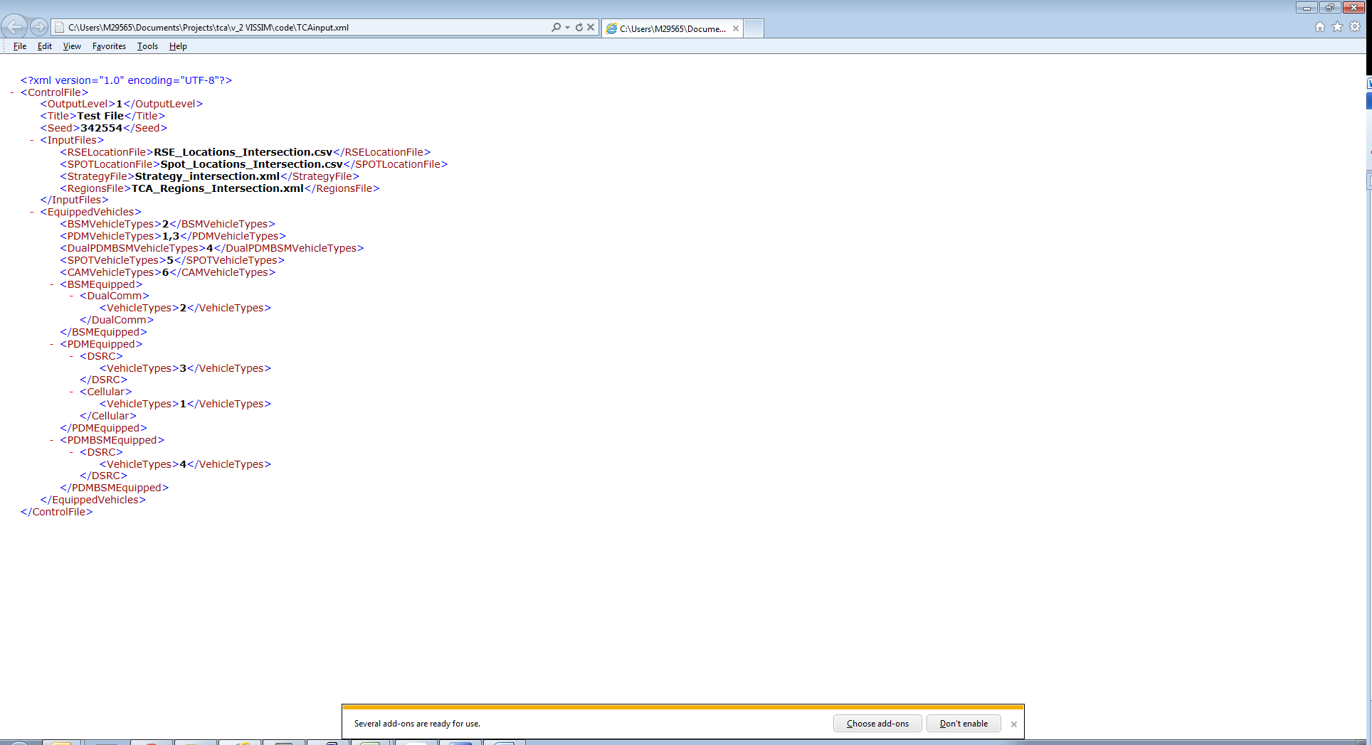

Figure ‑: Control File example

## RSE Location File

The RSE Location file is a comma-delimited file that contains geographical location information for the RSEs. This file is only required if PDM and/or BSM vehicles will transmit via DSRC.

This file must have a header line and only the fields from Table 3‑3 in the exact order listed are required. An example of an RSE Location File is shown in Figure 3‑2.

Table ‑: RSE location file fields

| Column | Name | Description | Value | |
| --- | --- | --- | --- | --- |
| 1 | Name | String based name for RSE. This name is output in the TCA snapshots | Character String |
| 2 | X | X location of the RSE | Integer (meters) |
| 3 | Y | Y location of the RSE | Integer (meters) |
| 4 | Latency (optional) | Latency value associated with that RSE | Integer (seconds) |
| 5 | Loss Rate (optional) | Loss rate percentage associated with that RSE | Integer (0-100%) |

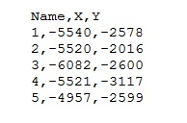

Figure ‑. RSE Locations File Example

## Strategy File

The Strategy file is an XML based file that stores all information for controlling how the TCA handles snapshot generation, RSE interaction, buffer management, gap management, and Probe Segment Number (PSN) generation. The Strategy file can be set to run the J2735 standard or several variations of the standard. Every element has a default value so a Strategy file is only necessary if the user wants to change the value of an element. For example, PSN gaps are turned off by default and a Strategy file must be used to turn them on and change the gap parameters if desired (see Figure 3‑3).

Elements that are required for different TCA model variations are noted with their respective symbol. (see Table 3‑4). The Strategy file has the fields in Table 3‑5 and an example is shown in Figure 3‑3.

Table ‑. Symbol Key

| Symbol | Description | |
| --- | --- | --- |
| C:\Users\M29565\AppData\Local\Microsoft\Windows\Temporary Internet Files\Content.IE5\315YD8PJ\MC900433804[1].png | Required element for a DSRC model |
| C:\Users\M29565\AppData\Local\Microsoft\Windows\Temporary Internet Files\Content.IE5\OZ4HO43N\MC900441494[1].png | Required element when PSN Gaps are enabled |
| No Symbol | Always Optional |

Table ‑: Strategy file fields

| Sym. | Root Element(s) | Element | Description | Value | |
| --- | --- | --- | --- | --- | --- |
|  | Strategy | Title | Title of the strategy | Character String |
|  | Inputs/PDM | TimeBeforePDMCollection | The time a vehicle must be active on the network before generating PDM snapshots | Integer (sec) |
|  | Inputs/PDM | DistanceBeforePDMCollection | The distance a vehicle must be active on the network before generating PDM snapshots | Integer (sec) |
| C:\Users\M29565\AppData\Local\Microsoft\Windows\Temporary Internet Files\Content.IE5\315YD8PJ\MC900433804[1].png  * | Inputs/  PDM/  PSNStrategy | TimeBetweenPSNSwitches  *Only required if the element below is not defined | Time between PSN changes | Integer (seconds) |
| C:\Users\M29565\AppData\Local\Microsoft\Windows\Temporary Internet Files\Content.IE5\315YD8PJ\MC900433804[1].png** | Inputs/  PDM/  PSNStrategy | DistanceBetweenPSNSwitches  **Only required if the element above is not defined | Distance between PSN changes | Integer (feet) |
| C:\Users\M29565\AppData\Local\Microsoft\Windows\Temporary Internet Files\Content.IE5\315YD8PJ\MC900433804[1].png | Inputs/  PDM/  PSNStrategy | Gap | Gap Setting for TCA:  0-No gaps  1-Gaps on | Integer |
| C:\Users\M29565\AppData\Local\Microsoft\Windows\Temporary Internet Files\Content.IE5\OZ4HO43N\MC900441494[1].png | Inputs/  PDM/  PSNStrategy/  GapInformation | MinTime | Min time in seconds for random generation of gap | Integer (seconds) |
| C:\Users\M29565\AppData\Local\Microsoft\Windows\Temporary Internet Files\Content.IE5\OZ4HO43N\MC900441494[1].png | Inputs/  PDM/  PSNStrategy/  GapInformation | MaxTime | Max time in seconds for random generation of gap | Integer (seconds) |
| C:\Users\M29565\AppData\Local\Microsoft\Windows\Temporary Internet Files\Content.IE5\OZ4HO43N\MC900441494[1].png | Inputs/  PDM/  PSNStrategy/  GapInformation | MinDistance | Min distance in feet for random generation of gap | Integer (feet) |
| C:\Users\M29565\AppData\Local\Microsoft\Windows\Temporary Internet Files\Content.IE5\OZ4HO43N\MC900441494[1].png | Inputs/  PDM/  PSNStrategy/  GapInformation | MaxDistance | Max distance in feet for random generation of gap | Integer (feet) |
| C:\Users\M29565\AppData\Local\Microsoft\Windows\Temporary Internet Files\Content.IE5\315YD8PJ\MC900433804[1].png | Inputs/  PDM/  StopStartStrategy | StrategyID | Stop/Start Strategy can be:  1 - Max time and speed (both time and speed trigger start/ stop snapshot)  2 - Max Distance or time (either distance traveled or time motionless triggers start/stop) | Integer |
| C:\Users\M29565\AppData\Local\Microsoft\Windows\Temporary Internet Files\Content.IE5\315YD8PJ\MC900433804[1].png | Inputs/  PDM/  StopStartStrategy | StopThreshold | Vehicle must be stopped at least this long to create a stop snapshot | Integer (seconds) |
| C:\Users\M29565\AppData\Local\Microsoft\Windows\Temporary Internet Files\Content.IE5\315YD8PJ\MC900433804[1].png | Inputs/  PDM/  StopStartStrategy | StopLag | Time in seconds that must pass before a 2nd stop snapshot can be taken | Integer (seconds) |
| C:\Users\M29565\AppData\Local\Microsoft\Windows\Temporary Internet Files\Content.IE5\315YD8PJ\MC900433804[1].png | Inputs/  PDM/  StopStartStrategy | StartThreshold | Speed in mph that a vehicle must have after a stop before a start snapshot can be taken | Integer (mph) |
| C:\Users\M29565\AppData\Local\Microsoft\Windows\Temporary Internet Files\Content.IE5\315YD8PJ\MC900433804[1].png | Inputs/  PDM/  StopStartStrategy | MultipleStops | Can more than one stop SS in a row be taken, 0-false 1-true | Integer |
| C:\Users\M29565\AppData\Local\Microsoft\Windows\Temporary Internet Files\Content.IE5\315YD8PJ\MC900433804[1].png | Inputs/  PDM/  PeriodicStrategy | StrategyID | Periodic Strategy can be:  1 - Speed interpolation (Periodic SS taken based on speed value) | Integer |
| C:\Users\M29565\AppData\Local\Microsoft\Windows\Temporary Internet Files\Content.IE5\315YD8PJ\MC900433804[1].png | Inputs/  PDM/  PeriodicStrategy | LowSpeedThreshold | The time to the next periodic snapshot uses these values. If the vehicle’s speed is below the LowSpeedThreshold, the ShortSpeedinterval is used as the time to the next periodic. If the vehicle’s speed is above the HighSpeedThreshold, the LongSpeedinterval is used. If the speed is between the thresholds, the time is interpolated. | Integer(mph) |
| C:\Users\M29565\AppData\Local\Microsoft\Windows\Temporary Internet Files\Content.IE5\315YD8PJ\MC900433804[1].png | Inputs/  PDM/  PeriodicStrategy | ShortSpeedInterval | See LowSpeedThreshold | Integer (seconds) |
| C:\Users\M29565\AppData\Local\Microsoft\Windows\Temporary Internet Files\Content.IE5\315YD8PJ\MC900433804[1].png | Inputs/PDM/ PeriodicStrategy | HighSpeedThreshold | See LowSpeedThreshold | Integer (mph) |
| C:\Users\M29565\AppData\Local\Microsoft\Windows\Temporary Internet Files\Content.IE5\315YD8PJ\MC900433804[1].png | Inputs/  PDM/  PeriodicStrategy | LongSpeedInterval | See LowSpeedThreshold | Integer (seconds) |
| C:\Users\M29565\AppData\Local\Microsoft\Windows\Temporary Internet Files\Content.IE5\315YD8PJ\MC900433804[1].png | Inputs/  PDM/  PeriodicStrategy | MaxDeltaSpeed | Percentage change in speed, periodic strategy 2 only | Float |
| C:\Users\M29565\AppData\Local\Microsoft\Windows\Temporary Internet Files\Content.IE5\315YD8PJ\MC900433804[1].png | Inputs/  PDM/  BufferStrategy | TotalCapacity | Snapshot capacity for the buffer | Integer |
| C:\Users\M29565\AppData\Local\Microsoft\Windows\Temporary Internet Files\Content.IE5\315YD8PJ\MC900433804[1].png | Inputs/  PDM/  BufferStrategy | SSRetention | Buffer Retention Strategy can be:  1 – FIFO  2 – Every other snapshot  3 – Every other plus keep the first and the last IDs  4 – Every other plus save the oldest SS | Integer |
|  | Inputs/PDM | DSRCFrequency or CellularFrequency | Minimum time required between DSRC/Cellular transmissions of PDMs | Float (seconds) |
| C:\Users\M29565\AppData\Local\Microsoft\Windows\Temporary Internet Files\Content.IE5\315YD8PJ\MC900433804[1].png | Inputs/  DSRC/  RSEInformation | MinRSERange | Minimum range in feet that vehicles can communicate to RSEs | Integer (feet) |
| C:\Users\M29565\AppData\Local\Microsoft\Windows\Temporary Internet Files\Content.IE5\315YD8PJ\MC900433804[1].png | Inputs/  DSRC/  RSEInformation | MaxRSERange | Maximum range in feet that vehicles can communicate to RSEs | Integer (feet) |
| C:\Users\M29565\AppData\Local\Microsoft\Windows\Temporary Internet Files\Content.IE5\315YD8PJ\MC900433804[1].png | Inputs/  DSRC/  RSEInformation | TimeoutRSE | Time in seconds that must pass before a vehicle can communicate with an RSE after just communicating with one | Integer (seconds) |
| C:\Users\M29565\AppData\Local\Microsoft\Windows\Temporary Internet Files\Content.IE5\315YD8PJ\MC900433804[1].png | Inputs/  DSRC/  RSEInformation | MinNumberofPDMtoTransmitViaDSRC | Minimum number of PDMs to transmit | Integer |
|  | Inputs/BSM | BrakeThreshold | Deceleration threshold when brakes are considered to be applied | Float (ft/s2) |
|  | Inputs/BSM | DSRCFrequency or CellularFrequency | Minimum time required between DSRC/Cellular transmissions of BSMs | Float (seconds) |
|  | Inputs/SPOT | DeviceRange | Maximum range in feet that vehicles can communicate to an ITS Spot device | Float (ft) |

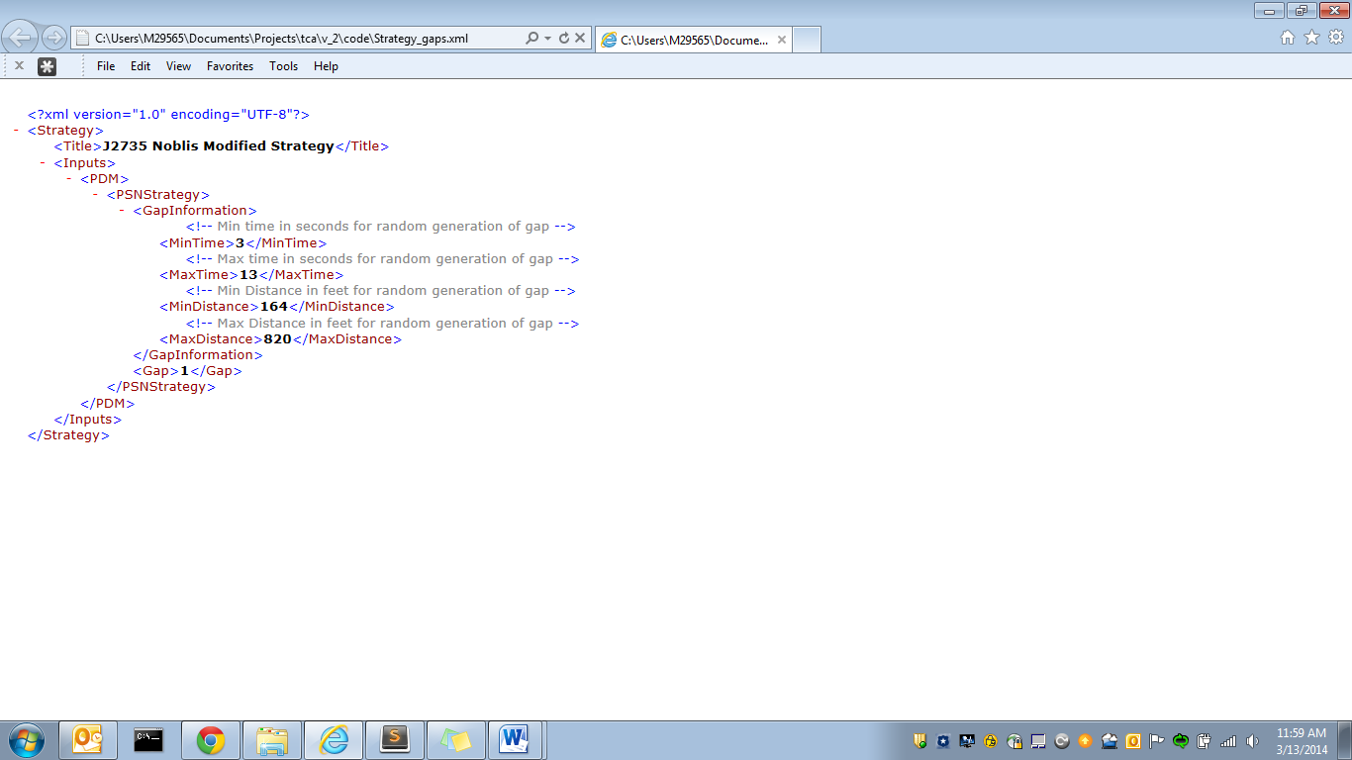

Figure ‑: Strategy input file example

## Regions File

The Regions file is an optional XML based input file that describes cellular and/or event regions. By default, any PDMs or BSMs transmitted via cellular will have no latency and 0% loss rate. These defaults can be modified using the Regions file. The user can also add rectangular cellular regions to model areas that have different loss rates or latency.

Event regions could model weather or other events that might, for example, cause a driver to turn on their wipers or for a vehicle to enable their traction control. Event regions are rectangular and defined by the upper left and lower right coordinates. Event regions can contain multiple events and multiple time periods when the events are active.

Each event within a region requires a name, a probability of occurrence, and a recheck value. Event names are automatically included as columns in the BSM output data. Events are rechecked for occurrence as defined by the recheck value. The recheck value is always static except when the user defines a Poisson distribution. A Poisson is one of three possible types of user-defined probability listed below:

1. Standard deviation: user provides a mean value and a standard deviation value and the TCA returns values based on a normal distribution.(Example region event: Air Temp)
2. Standard probability: user defines a probability of occurrence for an event, then TCA determines if the event happens based on the probability and returns either true or false (Example region event: traction control)
3. Poisson distribution: user defines a probability of the event and the TCA uses a Poisson distribution for rechecks (Example region event: wipers)

An example of event regions for a simple intersection network is pictured in Figure 3‑4. This example features three regions: two regions that use a standard deviation to determine the “Air Temp” and one region that contains two events, wipers and traction control, which use standard probability and a Poisson distribution, respectively.



Figure ‑: Example of regions over a simple intersection network

Table ‑: Regions file elements

| Root Element | Element(s) | Description | Value |
| --- | --- | --- | --- |
| Regions/Cell_Regions | DefaultLossPercent | The default loss percentage of snapshots transmitted via cellular | Integer |
| Regions/Cell_Regions | DefaultLatency | The default latency value between snapshot transmission and receive time | Integer (sec) |
| Regions/Cell_Regions | MinPDMtoTransmit | Minimum number of PDMs in the vehicle buffer necessary for PDM transmission | Integer |
| Regions/Cell_Regions/  Cell_Region | Title | Title of the cellular region | Character String |
| Regions/Cell_Regions/  Cell_Region/  UpperLeftPoint | X | The x-coordinate of the upper left point of the cellular region rectangle | Float (meters) |
| Regions/Cell_Regions/  Cell_Region/  UpperLeftPoint | Y | The y-coordinate of the upper left point of the cellular region rectangle | Float (meters) |
| Regions/Cell_Regions/  Cell_Region/  LowerRightPoint | X | The x-coordinate of the lower right point of the cellular region rectangle | Float (meters) |
| Regions/Cell_Regions/  Cell_Region/  LowerRightPoint | Y | The y-coordinate of the lower right point of the cellular region rectangle | Float (meters) |
| Regions/Cell_Regions/  Cell_Region | LossPercent | Loss percentage of messages transmitted within the defined cellular region | Integer |
| Regions/Cell_Regions/  Cell_Region | Latency | The latency between snapshot transmission from vehicle and received time of cell tower in the defined region | Float (sec) |
| Regions/Event_Regions/  Region | Title | Title of the event region | Character String |
| Regions/Event_Regions/  Region/UpperLeftPoint | X | The x-coordinate of the upper left point of the event region rectangle | Float (meters) |
| Regions/Event_Regions/  Region/UpperLeftPoint | Y | The y-coordinate of the upper left point of the event region rectangle | Float (meters) |
| Regions/Event_Regions/  Region/LowerRightPoint | X | The x-coordinate of the lower right point of the event region rectangle | Float (meters) |
| Regions/Event_Regions/  Region/LowerRightPoint | Y | The y-coordinate of the upper left point of the event region rectangle | Float (meters) |
| Regions/Event_Regions/  Region/TimePeriods/  Period | StartTime | The start time of a defined active time period for the region | Float (sec) |
| Regions/Event_Regions/  Region/TimePeriods/  Period | EndTime | The end time of a defined active time period for the region | Float (sec) |
| Regions/Event_Regions/  Region/Events/Event | Title | Title of an event within the region, this title will be the name of the data element in the BSM output | Character String |
| Regions/Event_Regions/  Region/Events/Event | Mean, SD, and Recheck | This probability option is to define a standard deviation and a mean. The recheck value for this probability type is static. | Integer |
| Regions/Event_Regions/  Region/Events/Event | Probability and Recheck | This method of probability sets a static probability of occurrence and a static recheck value | Integer |
| Regions/Event_Regions/  Region/Events/Event | Probability and RecheckPoisson | This method of probability uses a poisson distribution on a recheck value to determine the next recheck value, commonly used method for human interaction events | Integer |

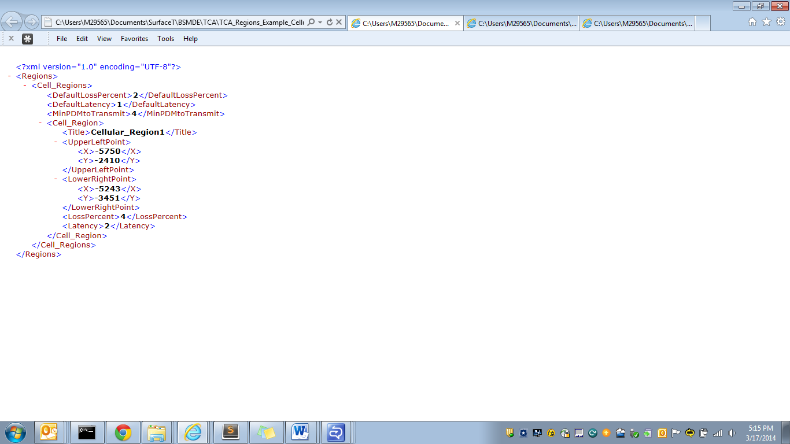

Figure ‑: Example regions input file with one cellular region

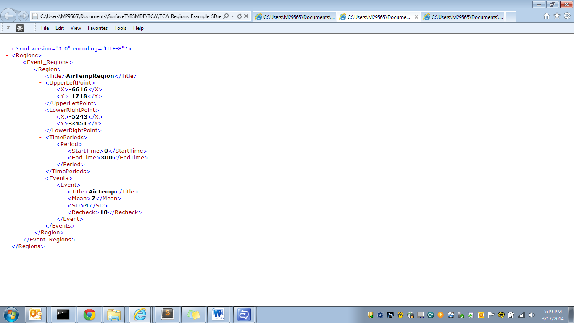

Figure ‑: Example region input file using the standard deviation method

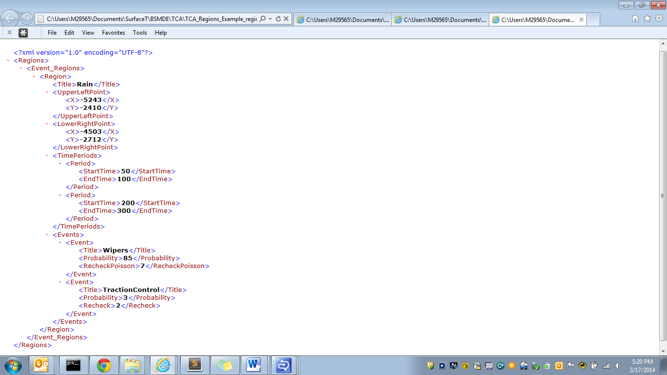

Figure ‑: Example regions input file using probability and Poisson distribution methods

## ITS Spot Device Location File

The ITS Spot Device Location file is a comma-delimited file that contains geographical location information for the ITS Spot devices. This file is only required if vehicles are equipped with ITS Spot-compatible systems.

This file must have a header line and only the fields from Table 3‑7 in the exact order listed. An example of an ITS Spot Device Location File is shown in Figure 3‑8.

Table ‑: ITS Spot device file fields

| Column | Name | Description | Value | |
| --- | --- | --- | --- | --- |
| 1 | Name | String based name for ITS Spot Device. | Character String |
| 2 | X | X location of the ITS Spot device | Integer (meters) |
| 3 | Y | Y location of the ITS Spot device | Integer (meters) |



Figure ‑: Sample ITS Spot device location file

# Output Files

## TCA Input Summary File

The TCA Input Summary File is a comma-delimited file that is always produced and lists every Control and Strategy element and their values. This file also includes an error message if an element is incorrectly defined. The file contains the items from Table 4‑1 for each element of the Control and Strategy files. An excerpt of an example TCA Input Summary file is shown in Figure 4‑1.

Table ‑. TCA Input Summary file fields

|  |  |  |
| --- | --- | --- |
| Column | Description | |
| FILE | The name of the file, either the name of the Control or Strategy file, from which the element is located |
| NAME | Name of the element |
| VALUE | Value of the element |
| XML_TAG | The XML tag of the element |
| TYPE | Can be either Default or User-Defined |
| ERRORS | Error message, if any |

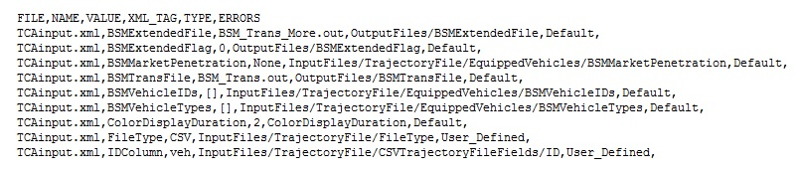

Figure ‑. TCA Input Summary file example excerpt

## Transmitted PDMs File

The Transmitted PDM file is a comma delimited file that stores all PDM snapshot information that is transmitted to RSEs or via cellular, based on the RSE or cellular region locations and the strategy implemented in the TCA. The first line of the Transmitted Snapshot file is a header line describing all of the fields. The Transmitted Snapshot file contains the data elements from Table 4‑2 on each line.

Table ‑: Transmitted PDMs file fields

| Column | Name | Description | Value | |
| --- | --- | --- | --- | --- |
| 1 | DSRC_MessageID | Static value of 09, data element used to tell the receiving application how to decode the message type | String |
| 2 | Time_Taken | Time that the snapshot was taken | Integer |
| 3 | PSN | The PSN number for the snapshot | Integer |
| 4 | Speed | Speed in mph that the vehicles were going then the snapshot was taken | Float (mph) |
| 5 | Location_X | X value in feet for the location of the vehicle when the snapshot was taken | Integer (feet) |
| 6 | Location_Y | Y value in feet for the location of the vehicle when the snapshot was taken | Integer (feet) |
| 7 | Msg_Type | Snapshot type (1-stop, 2-start, 3- periodic) | Integer |
| 8 | Transmit_To | RSE or cellular region the snapshot was transmitted to | Character String |
| 9 | Transmit_Time | The time the snapshot was transmitted | Integer |
| 10 | Message_SS_Number | The order of the message within a transmission. Snapshots are transmitted in messages containing up to 4 snapshots | Integer |
| 11 | Vehicle_SS_Number | Position of the snapshot within the message | Integer |
| 12 | Received_Time | Time that the snapshot was received (accounts for latency if applicable) | Integer |

## All PDM Snapshots File

The All PDM Snapshots file is a comma delimited file that stores all PDM snapshot information including PDM snapshots that were deleted and not transmitted. This file includes: type of snapshot taken, vehicle ID, whether the snapshot was deleted and why. The first line of the All Snapshots file is a header with all the field titles. The All PDM Snapshots file has the fields listed in Table 4‑3.

Table ‑: All PDM snapshots file fields

|  |  |  |  |  |
| --- | --- | --- | --- | --- |
| Column | Name | Description | Value | |
| 1 | DSRC_MessageID | Static value of 09, data element used to tell the receiving application how to decode the message type | String |
| 2 | Vehicle_ID | ID of the vehicles as stated in the vehicle trajectory file | Character String |
| 3 | SS_Count | Total number of snapshots by all vehicles, starting at 1 | Integer |
| 4 | Time_Taken | Time that the snapshot was taken | Integer |
| 5 | PSN | The PSN number for the snapshot | Integer |
| 6 | Speed | Speed in mph that the vehicles were going then the snapshot was taken | Float (mph) |
| 7 | Location_X | X value in feet for the location of the vehicle when the snapshot was taken | Integer (feet) |
| 8 | Location_Y | Y value in feet for the location of the vehicle when the snapshot was taken | Integer (feet) |
| 9 | Last_RSE | The name of the last RSE that the vehicle transmitted to (only included if RSEFlag option is turned on in the Strategy file) | Character String |
| 10 | Msg_Type | Snapshot type (1-stop, 2-start, 3- periodic) | Integer |
| 11 | Transmit_Time | The time the snapshot was transmitted to an RSE (-1 if not transmitted) | Integer |
| 12 | Transmit_To | RSE or cellular region the snapshot was transmitted to (-1 if not transmitted) | Character String |
| 13 | Delete_Time | Time the snapshot was deleted from the buffer. This value is 0 if the snapshot was not deleted | Integer |
| 14 | Delete_Reason | Reason the snapshot was deleted (0-Not deleted, 1- Buffer overload, 2-Left in the buffer after the vehicle trajectory stopped, 3-PSN rollover gap, 4- RSE interaction, 5- Snapshot lost during cellular transmission) | Integer |

## Transmitted BSM File

The Transmitted BSM file is a comma delimited file that stores all BSM snapshot information that is transmitted via DSRC or cellular, based on the RSE or cellular region locations and the strategy implemented in the TCA. The first line of the Transmitted BSM file is a header line describing all of the fields. The Transmitted BSM file contains the data elements from Table 4‑4 on each line as well as any additional region elements defined in the Regions input file.

Table ‑: Transmitted BSM file fields

| Name | Description | Value | |
| --- | --- | --- | --- |
| DSRC_MessageID | Static value of 09, data element used to tell the receiving application how to decode the message type | String |
| Vehicle_ID | ID of the vehicles as stated in the vehicle trajectory file | Character String |
| BSM_tmp_ID | Temporary ID that changes every 5 minutes | Integer |
| transtime | Time that the snapshot was taken and transmitted | Integer |
| Location_X | X value in feet for the location of the vehicle when the snapshot was taken | Integer (feet) |
| Location_Y | Y value in feet for the location of the vehicle when the snapshot was taken | Integer (feet) |
| Speed | Speed in mph that the vehicle was going when the snapshot was taken | Float (mph) |
| Heading | The heading of the vehicle (between 0 and 360 degrees) | Float (degrees) |
| instant_accel | Instantaneous acceleration of the vehicle (if available from the input) | Float (ft/s2) |
| avg_accel | Average acceleration that the vehicle was going between the previous snapshot and the current snapshot | Float (ft/s2) |
| brakePressure | The deceleration value or zero if the vehicle is accelerating (vehicle instantaneous acceleration value required for this output) | Float (ft/s2) |
| brakeStatus | Notes the brakes applied status of each wheel independently. Brakes are either off (0000) or on (1111) as determined by the brake threshold value in the Control input file (vehicle instantaneous acceleration value required for this output) | Character String |
| hardBraking | Is either true or false if the vehicle is hard braking (vehicle instantaneous acceleration value required for this output) | Character String |
| transTo | The name of the RSE or Cellular region the BSM was transmitted to | Character String |
| Transmission_received_time | Time the BSM was received | Integer (sec) |
| Transtime | Time the BSM was transmitted | Integer (sec) |

## Transmitted CAM File

The transmitted CAM file is a comma delimited file that stores all CAM message information transmitted via DSRC. The first line of the Transmitted CAM file is a header line describing each field. The Transmitted CAM file contains the data elements from Table 4‑5 on each line.

Table ‑: Transmitted CAM file fields

| Name | Description | Value | |
| --- | --- | --- | --- |
| Protocol Version | Version of the ITS message; 1 for current version. | Integer |
| Message ID | Message type of the ITS message; 2 for CAM. | Integer |
| Station ID | The unique numerircal identifier of the ITS-S that generates message | Integer |
| Generation Delta Time | Time of message generation | Integer (milliseconds) |
| Station Type | The type of an ITS-S; 5 for passenger car | Integer |
| Latitude | The vehicle’s latitude | Integer |
| Longitude | The vehicle’s longitude | Integer |
| Semi Major Confidence | Part of position confidence ellipse; 4095 for unavailable | Integer |
| Semi Minor Confidence | Part of position confidence ellipse; 4095 for unavailable | Integer |
| Altitude Value | Part of reference position; 800001 for unavailable | Integer |
| Heading Value | Orientation of a heading with regards to north | Float (degrees) |
| Heading Confidence | Absolute accuracy of heading value; 127 for unavailable | Integer |
| Speed | Speed of the vehicle in meters per second | Float (m/s) |
| Speed Confidence | Absolute accuracy of the speed value; 127 for unavailable | Integer |
| Drive Direction | Direction vehicle is moving; 0 for forward, 1 for backward, 2 for unavailable | Integer |
| Longitudinal Acceleration Value | Vehicle acceleration at longitudinal direction; 162 if unavailable | Float (m/s2) |
| Curvature Value | The inverse of the vehicle turning curve radius; 30001 for unavailable | Integer |
| Curvature Confidence | The absolute accuracy range of curvature value; 7 for unavailable | Integer |
| Yaw Rate Value | Vehicle rotation around the z-axis centered on the center of mass | Float (degrees/second) |
| Yaw Rate Confidence | Absolute accuracy range of the yaw rate value; 8 for unavailable | Integer |
| Vehicle Length Value | Estimated length of vehicle; 1023 for unknown | Integer |
| Vehicle Length Confidence Indication | Indicates presence of trailer; 3 for unknown | Integer |
| Vehicle Width | Estimated width of vehicle; 62 for unknown | Integer |

## ITS Spot Travel Records

The ITS Spot travel records file is a comma delimited file that stores all the ITS Spot travel records transmitted via DSRC. The first line of the ITS Spot travel records file is a header line describing each field. The ITS Spot travel records file contains the data elements from Table 4‑6 on each line. An excerpt from an example file of transmitted ITS Spot travel records are shown in Figure 4‑2.

Table ‑: ITS Spot Travel Record file fields

| Name | Description | Value | |
| --- | --- | --- | --- |
| Time_Taken | Time that the ITS Spot record was taken | Integer (seconds) |
| X | X value in feet for the location of the vehicle when the ITS Spot record was taken | Float (ft) |
| Y | Y value in feet for the location of the vehicle when the ITS Spot record was taken | Float (ft) |
| Speed | Speed in km/hr that the vehicle was going when the ITS Spot record was taken | Float (km/hr) |

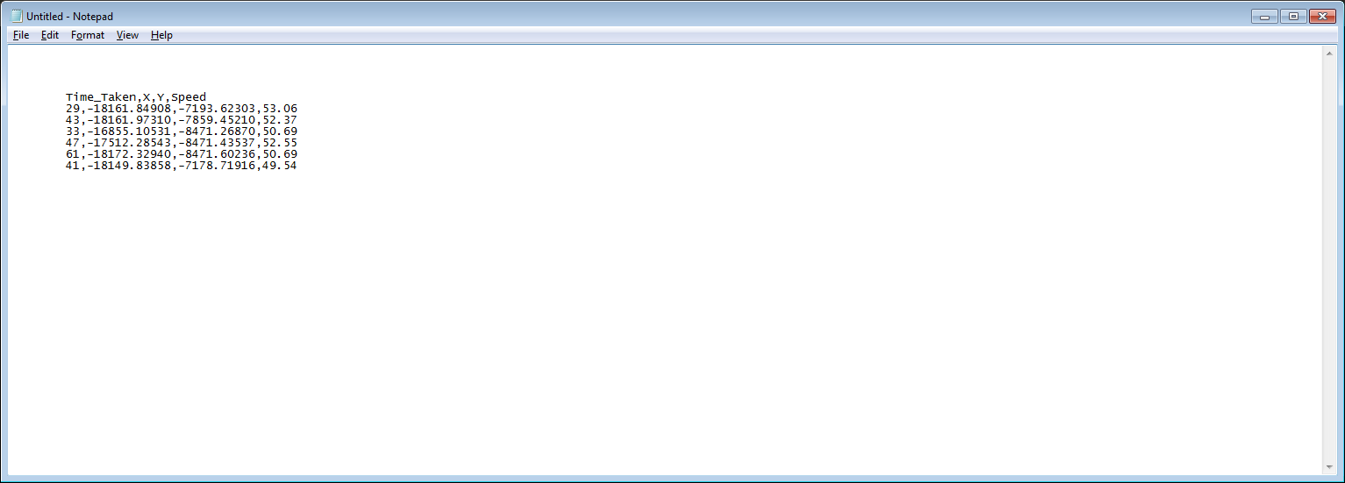

Figure ‑: ITS Spot travel records example excerpt

## ITS Spot Behavior Records

The ITS Spot travel records file is a comma delimited file that stores all the ITS Spot travel records transmitted via DSRC. The first line of the ITS Spot travel records file is a header line describing each field. The ITS Spot travel records file contains the data elements from Table 4‑7. An excerpt from an example file of transmitted ITS Spot behavior records is shown in Figure 4‑3.

Table ‑: ITS Spot Behavior Record file fields

| Name | Description | Value | | |
| --- | --- | --- | --- | --- |
| Time_Taken | Time that the ITS Spot record was taken | Integer (seconds) |
| X | X value in feet for the location of the vehicle when the ITS Spot record was taken | Float (ft) |
| Y | Y value in feet for the location of the vehicle when the ITS Spot record was taken | Float (ft) |
| Speed | Speed in km/hr that the vehicle was going when the ITS Spot record was taken | Float (km/hr) |
| Acceleration | Peak acceleration in g that the vehicle was going when the ITS Spot record was taken | Float (g) |
| Yaw Angular Velocity | Peak velocity in degrees/sec that the vehicle was experiencing when the ITS Spot record was taken | Float (deg/sec) | |

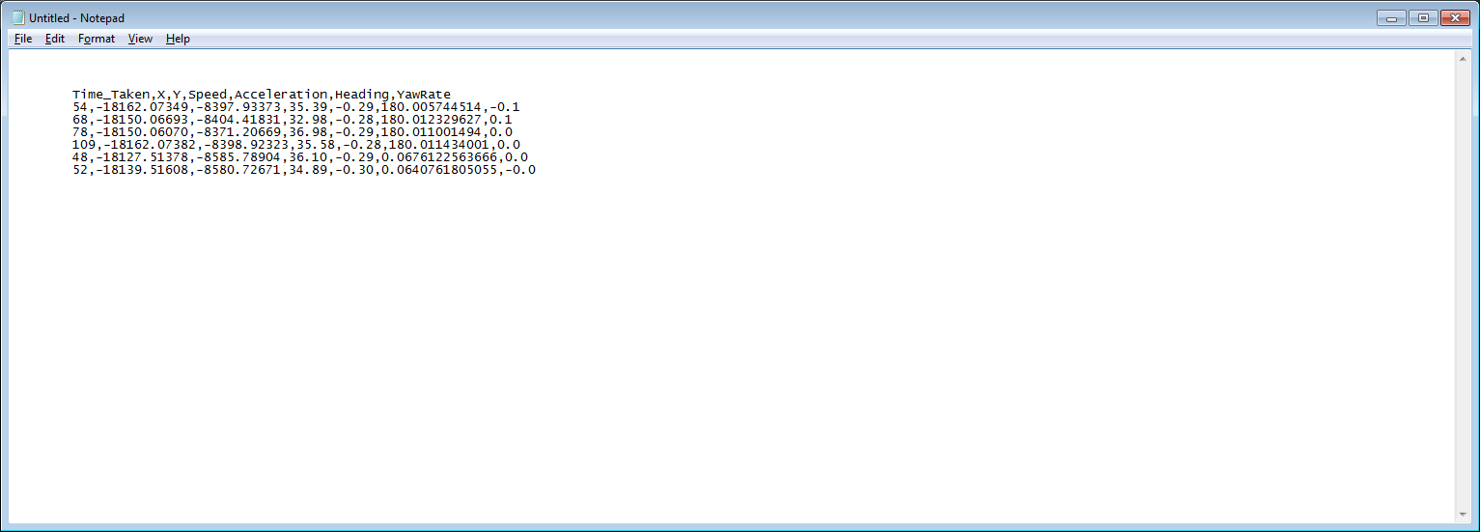

Figure ‑: ITS Spot behavior records example excerpt

U.S. Department of Transportation  
ITS Joint Program Office-HOIT  
1200 New Jersey Avenue, SE  
Washington, DC 20590  
  
Toll-Free “Help Line” 866-367-7487  
[www.its.dot.gov](http://www.its.dot.gov)  
  
FHWA-JPO-XX-XXX



Federal Highways Administration